Password Security Analysis Report
Date: January 20, 2026
Analyst: Nishanth C
Tools Used: JohntheRipper, Hashcat
Subject: Vulnerability Assessment of Stored Credentials
Phase 1: Testing
Step 1: Generate Target Hashes
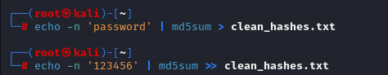
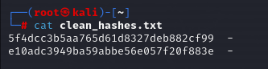
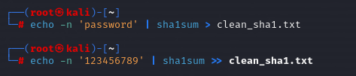
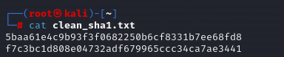
Step 2: The Attack Using JohnTheRipper
Run John The Ripper using default wordlist, resulting in a de-hashed output
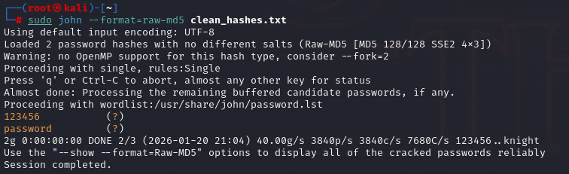
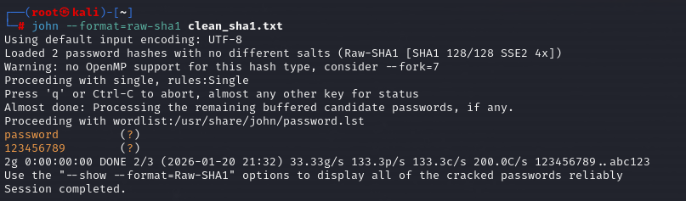
Step 3: The Attack Using Hashcat
Run Hashcat using rockyou.txt wordlist
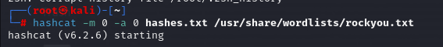
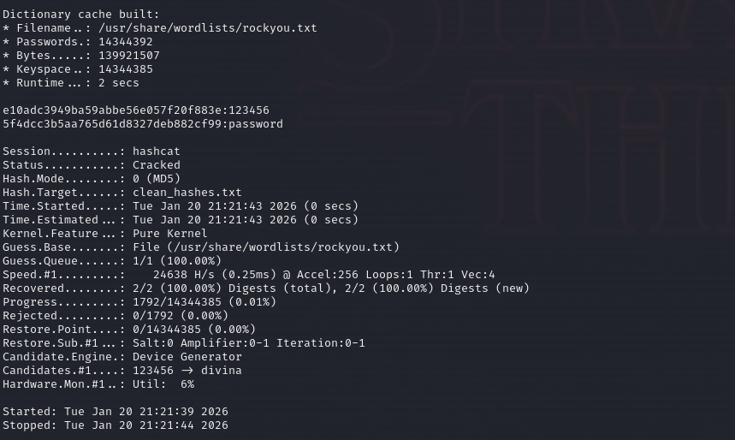
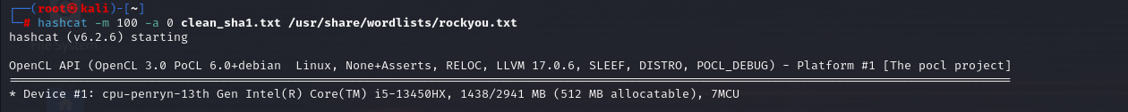
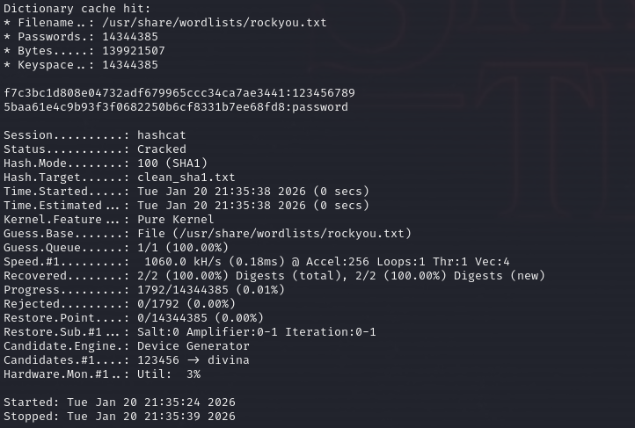
Phase 2: Technical Findings
Hash Type Status Time to Crack Vulnerability
MD5 Cracked 2 seconds Algorithm is cryptographically broken
and computationally too fast
SHA-1 Cracked < 1 Second Susceptible to collision attacks and
high-speed GPU cracking
Phase 3: Discussion
The analysis used a dictionary attack method.
- Target Acquisition: Weak hashes were generated to simulate a database dump.
- Tool Execution: JohntheRipper and Hashcat were employed to compare these hashes against rockyou.txt wordlist.
- Result: The tools successfully matched the hash to the plaintext instantly.
Phase 4: Vulnerability Analysis
- Weak Algorithm: MD5 allows millions of guesses per second, making brute-force attacks feasible for short passwords.
- Dictionary Weakness: Users relying on common words or predictable patterns are vulnerable to pre-computed wordlist attacks.
Recommended Fixes:
- Upgrade Hashing standards
- Enforce Multi-Factor Authentication
- Strengthen Password Policies
Conclusion
The current use of MD5 for credential storage represents a critical risk. Remediation requires an immediate shift on modern hashing standards and the mandatory implementation of MFA to mitigate the risk of credential compromise.

